Calibration process

# Data Calibration

First load the data. Data is coming from OECD and other fonts.

## Computing aggregate time series from individual country time series

The OECD dataset often aggregate time series for the OECD as a whole. In certain cases, such data does not exist. In order to obtain aggregate estimates, we use the following procedure: - obtain each country time-serie expressed as a percentage of GDP - compute a GDP-weighted average for the OECD, expressed as a share of GDP - multiply the obtained time series by OECD GDP to obtain an estimate of the aggregate flow (in USD)

# GDP Computation

We start with GDP. There are various reasons for that. One because GDP is one of the most used indicator. Second because, we will used GDP-weighted averages to compute some of the aggregates. We thus need a good approximation of OECD GDP and of the countries in order to compute the following time series.

## Closed economy hypothesis

The first hypothesis we use is that the OECD is a closed economy. This is easily controlled by looking at the OECD trade balance in % of GDP:

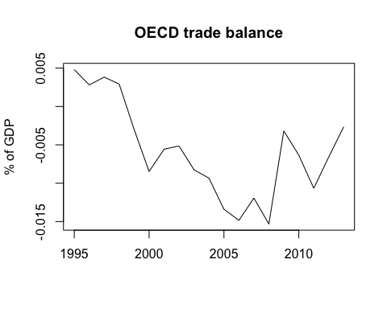

However, because the trade balance is not completely equal to zero, we need for one of the flow composing it to absorb the difference. We chose consumption, mostly because it is the main component of GDP. We can nonetheless check if this assumption does not impact too much the consumption time series. We see that Consumption is slightly underestimated as a result of our hypothesis.

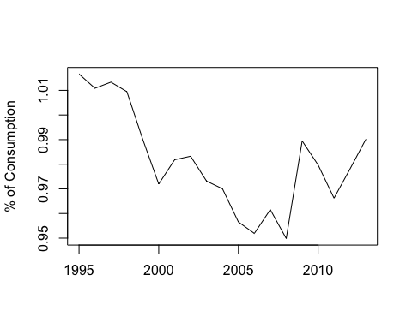

## Government expenditures and income

### Tax rate

We use countries average revenue data to compute the average tax rate, following the procedure expressed hereabove. The tax rate obtain is the following:

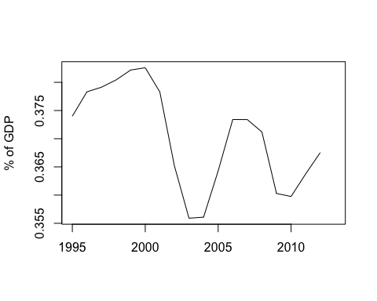

### Total expenditures

We use countries average deficit data to compute the average expenditures, using the previously computed total income. We differenciate between total public expenditures, i.e. containing interests payments and government expenditures, i.e. government consumption of goods and services. Once substractinf total expenditures from income, we obtain the public net lending position:

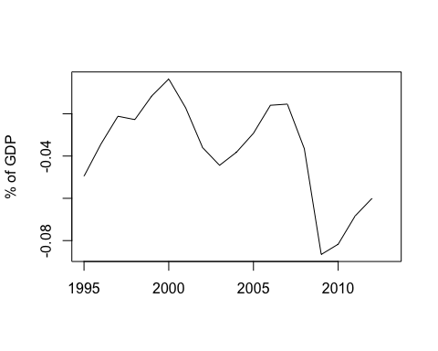

### Public debt

The public debt time series is then computed from the public net lending position (or savings). The average interest rate payed on this debt can be derived from the substraction between total public expenditure and government expenditure, divided then by the previous period stock of debt. we obtain thus the following time series for total debt and average interest rate.

